Experiment no.:02 Keerthika.K-241901046
Live Forensics Case Investigation using Autopsy

Aim:
To perform live forensic case investigation using Autopsy and analyze digital evidence from the selected data source.
Procedure:
- Download and install Autopsy forensic software on the system, if it is not already installed.
- Open Autopsy and select the New Case option.
- Enter the case name and base directory to save the case details.
- Enter the case number and examiner details, then click Finish.
- Select the Add Data Source option to add the evidence source for investigation.
- Choose the appropriate source type and browse the location of the evidence file or disk.
- Configure the required ingest modules to analyze the selected data source.
- Click Finish to start processing the data source and adding the evidence to the local database.
- Wait until the data processing is completed and the forensic results are generated.
- Examine the attached devices and available device information.
- Analyze the EXIF metadata, installed programs, operating system information, and user accounts.
- Examine recent documents, web bookmarks, web cookies, web downloads, web history, web searches, and available email addresses.
- Record the observations and analyze the available digital evidence for investigation.
Observation:
Autopsy is a digital forensic investigation tool used to examine digital evidence from a selected data source.
The following observations can be recorded during the experiment:
- The case was created successfully with the required case details.
- The selected data source was added for forensic examination.
- The ingest modules were configured to process the selected evidence.
- The forensic results were displayed after processing was completed.
- The available device details and operating system information could be examined.
- User accounts, installed programs, and recent documents could be analyzed.
- Available browser artifacts, including web history, bookmarks, cookies, and downloads, could be examined.
- The extracted information could be used to support digital forensic investigation.
Observation Table:
S. No. | Parameter | Observation
1 | Tool Used | Autopsy
2 | Operation | Live Forensics Case Investigation
3 | Case Creation | Case name and examiner details
4 | Data Source | Selected evidence source
5 | Processing | Ingest module processing
6 | Evidence Analysis | Device and operating system information
7 | User Information | User accounts and recent documents
8 | Browser Artifacts | Web history, bookmarks, cookies, and downloads
9 | Output | Forensic investigation results
10 | Status | Record the actual processing and investigation status

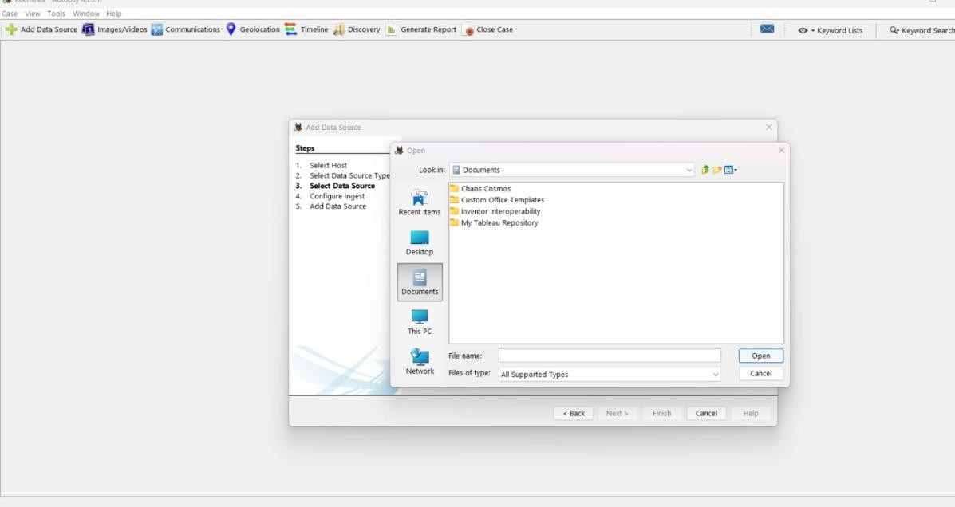

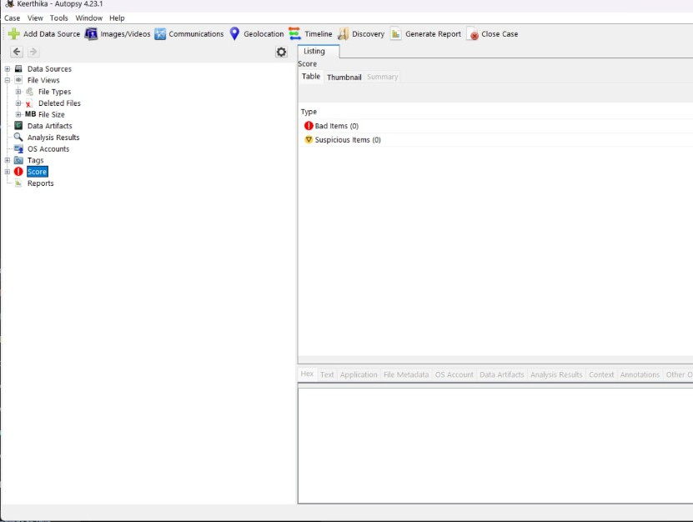

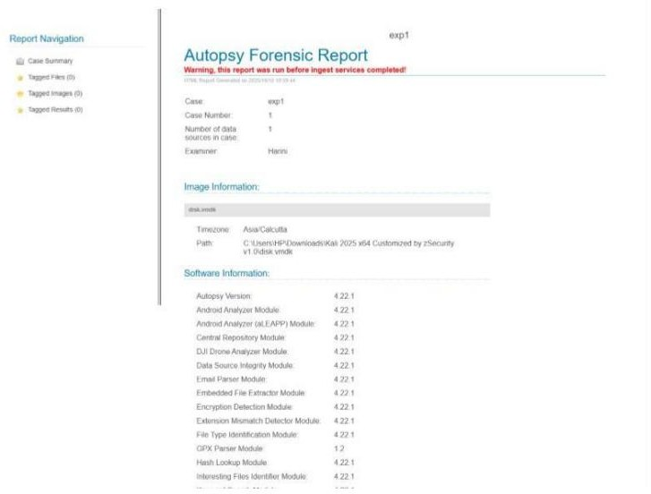

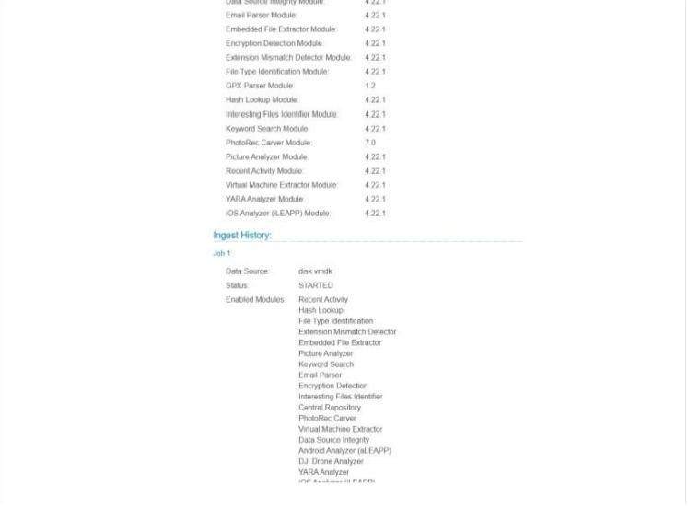

Result:
Thus, live forensic case investigation using Autopsy was studied and performed. The selected data source was processed, and the available digital evidence and forensic artifacts were examined successfully.

